INTEL UNNATI INTERNSHIP

PROJECT REPORT

PROJECT NAME:

DESIGN AND IMPLEMENTATION OF AUTOMATED TELLER MACHINE (FSM) USING VERILOG HDL AND FPGA

SUBMITTED BY

MERLA SATHWIK CHOWDARY

200907198

TEAM NAME: THE MAVERICK

DEPARTMENT OF ELECTRONICS AND COMMUNICATION ENGINEERING

MANIPAL INSTITUTE OF TECHNOLOGY

UDUPI-KARKALA ROAD, ESHWAR NAGAR, MANIPAL, KARNATAKA,576104

1. **INTRODUCTION:**

The provided code represents an ATM (Automated Teller Machine) implemented using a Mealy Finite State Machine (FSM) in Verilog HDL. The purpose of this code is to simulate the behavior of an ATM system, allowing users to perform various banking operations such as checking account balance, making withdrawals, deposits, and generating mini statements.

The ATM Mealy FSM module consists of several input and output signals. The input signals include 'clk' for the clock signal, 'reset' for resetting the ATM system, 'user_input' for receiving user input in binary format, 'amount' for specifying the withdrawal or deposit amount, and 'facial_recognition_result' indicating the result of facial recognition. The output signals include 'display' for displaying messages on the ATM screen, 'cash_dispenser' for activating the cash dispenser, 'account_lock' for indicating if the account is locked, 'balance' for displaying the current account balance, 'mini_statement' for storing the mini statement information, and 'mini_statement_present' for indicating whether the mini statement is available.

The Mealy FSM is implemented using a sequential always block that trigger on the positive edge of the clock signal or a reset signal. It utilizes a state variable 'state' to keep track of the current state of the ATM system. Each state represents a specific functionality of the ATM, such as PIN entry, withdrawal, deposit, etc. The FSM transitions from one state to another based on the user input and the current state.

Upon reset, the ATM system is initialized, and the state is set to the IDLE state. The user is prompted to enter their PIN. Based on the user input and the current state, the FSM progresses through different states to perform the requested operations. The ATM also incorporates a facial recognition feature to enhance security. If the facial recognition is successful, the ATM allows the user to proceed with the requested operation; otherwise, it takes appropriate actions based on the number of PIN entry attempts and the lock timer.

The FSM handles various scenarios such as account locking, withdrawal, deposit, balance display, and mini statement generation. It also keeps track of the account balance and recent transactions for providing accurate information to the user. The cash dispenser is activated when a successful withdrawal is made.

1. **Block diagram:**

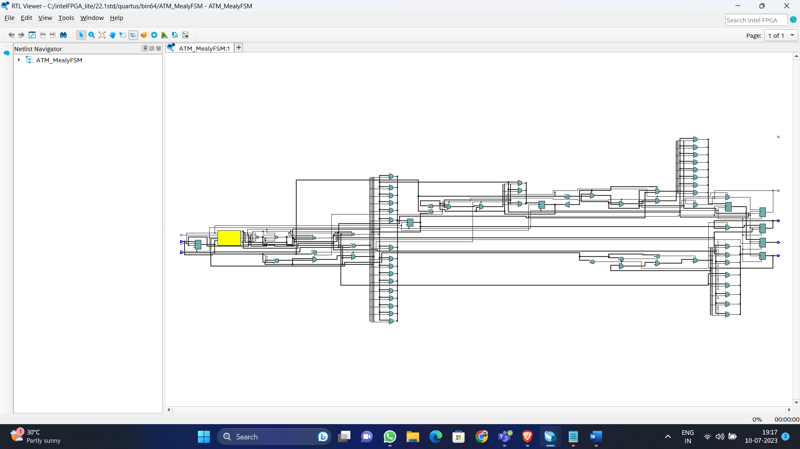

1. **FSM model**

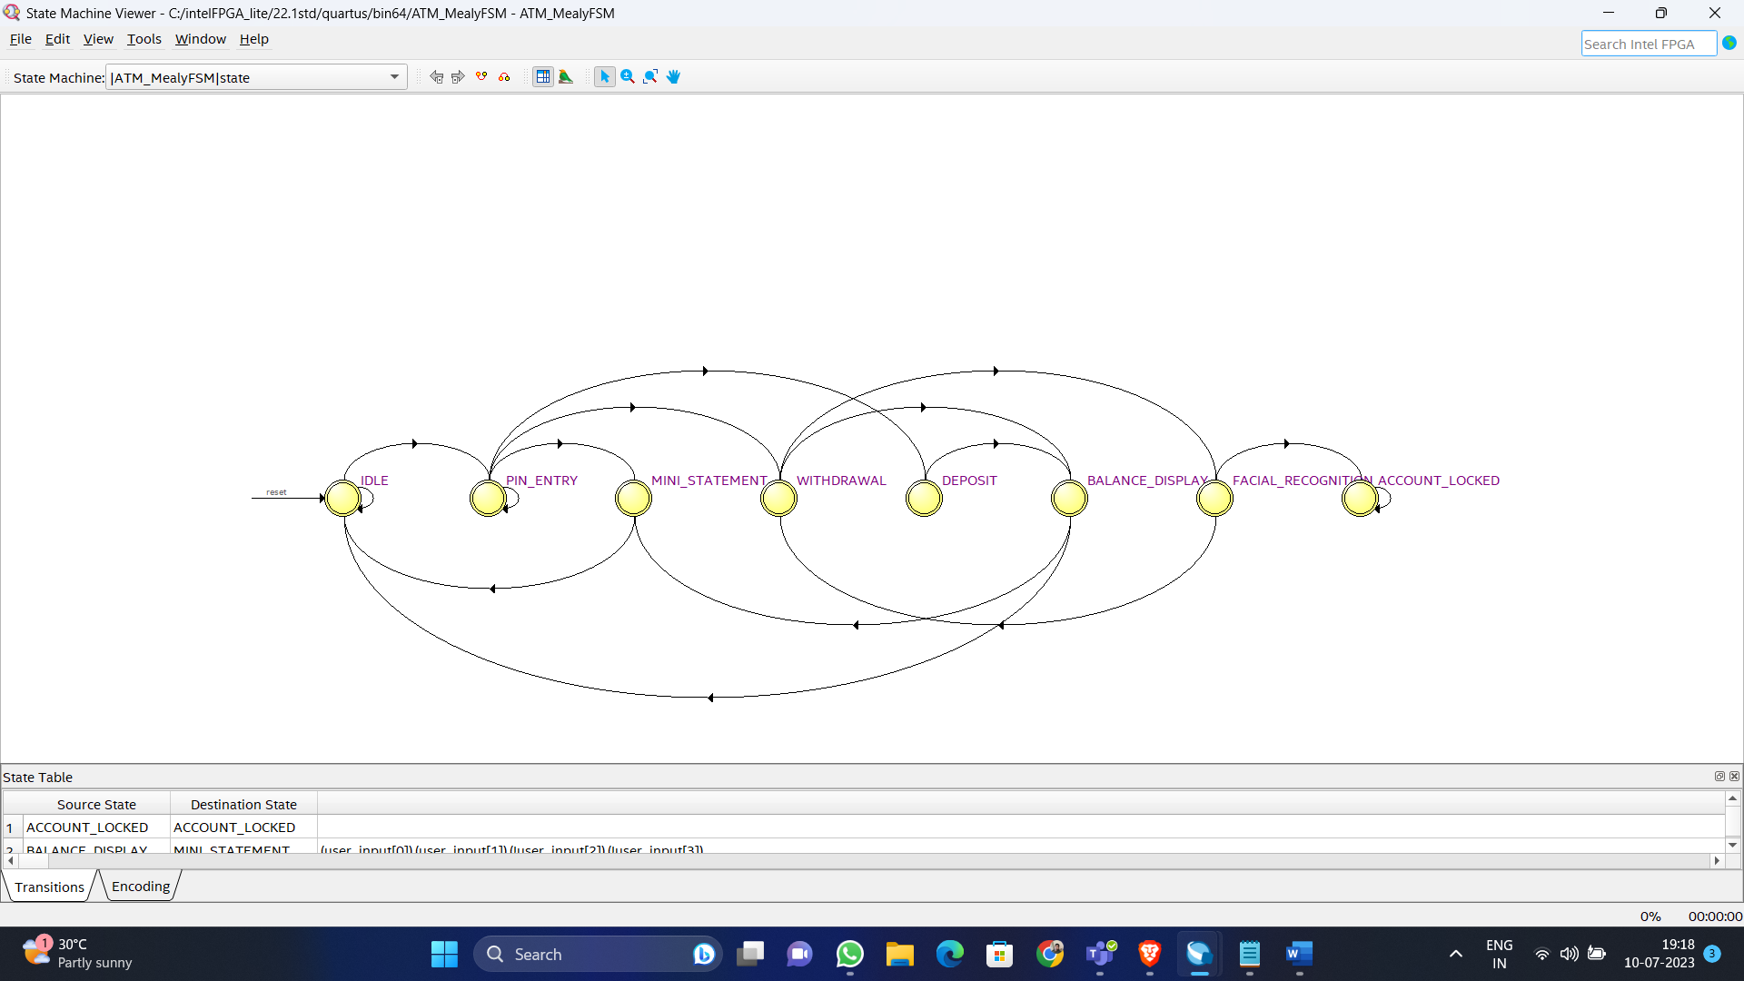

1. **Post fitter technology map**

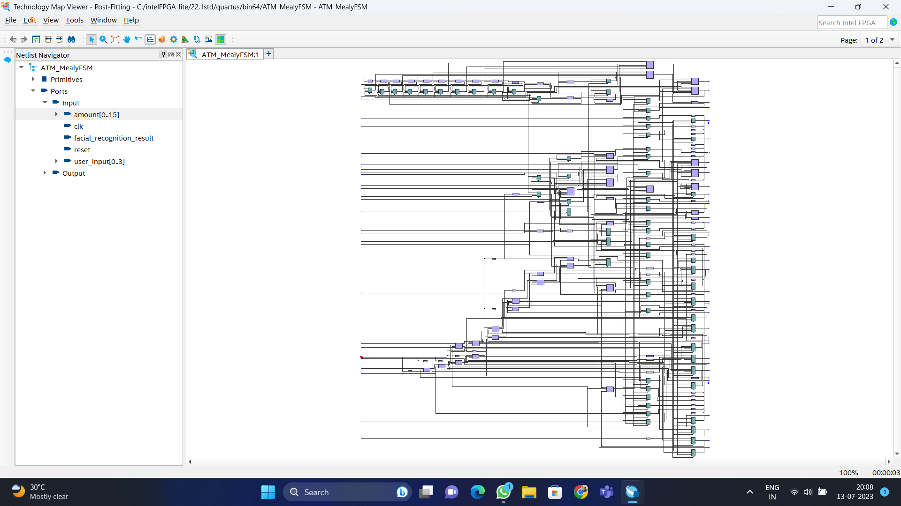

1. **Post mapping technology map**

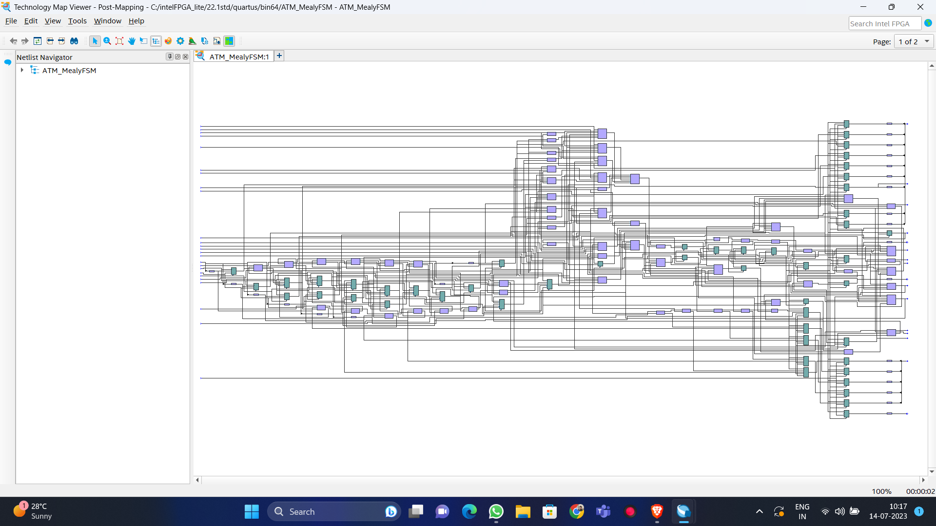

1. **Approach to Solve the Problem:**

The code you provided implements an ATM (Automated Teller Machine) using a Mealy finite state machine (FSM) approach. Here's a breakdown of the approach:

**Module Inputs and Outputs:**

**Inputs:**

* clk: Clock signal for the synchronous operation of the FSM.
* reset: Reset signal to initialize the FSM to its initial state.
* user_input: 4-bit input representing user commands or choices.
* amount: 16-bit input representing the transaction amount.
* facial_recognition_result: Input indicating the result of facial recognition.

**Outputs:**

* display: 8-bit output representing the display message to be shown on the ATM screen.
* cash_dispenser: Output indicating whether the cash dispenser should be activated.
* account_lock: Output indicating whether the user's account is locked.
* balance: 16-bit output representing the account balance.
* mini_statement: 8-bit output representing the mini statement of recent transactions.

**State and State Variables:**

* The FSM has eight states defined by three-bit values: IDLE, PIN_ENTRY, ACCOUNT_LOCKED, WITHDRAWAL, FACIAL_RECOGNITION, DEPOSIT, BALANCE_DISPLAY, and MINI_STATEMENT.
* The current state is stored in the state variable.

**Internal Variables:**

* pin_entry_attempts: 3-bit variable tracking the number of failed PIN entry attempts.
* account_balance: 16-bit variable representing the current account balance.
* withdrawal amount: 16-bit variable representing the amount to be withdrawn.
* Recent_transactions: 32-bit array storing the five most recent transactions.
* recent_transactions_count: 3-bit variable indicating the number of transactions stored in recent_transactions.
* i: 3-bit variable used for loop iteration.

**FSM Logic:**

* The FSM operates on the rising edge of the clock (posedge clk) or when a reset signal is received (posedge reset).
* On reset, all variables are initialized to their default values.
* The FSM's behaviour is defined by a case statement based on the current state.
* In each state, specific actions are performed based on the current inputs and state conditions.
* The actions include updating the variables, changing the state, and setting the output values accordingly.
* The display output is updated with the appropriate message for the ATM screen.
* The cash_dispenser and account_lock outputs control the activation of the cash dispenser and account lock mechanism, respectively.
* The balance output reflects the current account balance.
* The mini_statement output contains the recent transactions in a packed format.

**State Transitions:**

* The FSM transitions between states based on specific conditions and user inputs.
* For example, in the IDLE state, if the user enters the PIN as 0000, the FSM transitions to the PIN_ENTRY state.
* In the PIN_ENTRY state, the FSM checks for valid PIN entry, performs facial recognition if required, and transitions to other states based on the results.
* Similarly, other states handle withdrawal, deposit, balance display, mini statement generation, and account lock based on user inputs and current conditions.

1. **COMPLETE FLOW USED**

The ATM begins in the idle state, where it waits for user input. The user is required to enter the correct PIN (Personal Identification Number) to proceed. If the entered PIN is correct, the ATM transitions to the options state, where the user is presented with three choices: deposit, withdrawal, and mini statement.

In the deposit state, the user can deposit money into their account. The amount to be deposited is provided by the user, and the ATM updates the account balance accordingly. After the deposit, the ATM transitions to the balance display state, where it displays the updated account balance.

In the withdrawal state, the user can request to withdraw money from their account. If the withdrawal amount is greater than $10,000, the ATM requires facial recognition for security purposes. The facial recognition result is obtained from an external source. If the facial recognition is successful, the ATM dispenses the requested cash and updates the account balance. Additionally, a mini statement is made available, which contains information about the recent transactions. If the facial recognition fails, the ATM transitions to the account lock state.

In the mini statement state, the user can check their current balance and recent transactions or they can access the mini statement state and can return to the idle state. If mini_statement is 1, then it is generated and if mini_statement is 0, it is not generated.

In the balance display state, the user can access their current balance in their account and also after the withdrawal and deposit, the balance display state will be accessed.

In the account locked state, it will be accessed when the user fails in the facial recognition state or if the pin entered is invalid. The account will lock for 24 hours and will be unlocked after that time period. If account_lock is 1, then the account is locked and when the account_lock is 0 , then the account is not locked

In the facial recognition state, the user has to undergo the facial recognition for any withdrawal more than 10000. If the facial recognition passes, then they can withdraw the amount and return to the idle, if the facial recognition fails, then account will lock for 24 hours and will be unlocked after that. In the account lock state, the user's account is locked due to either entering an incorrect PIN or failing the facial recognition. The account remains locked for 24 hours, after which it automatically unlocks and transitions back to the idle state.

1. **Results:**

**Test Case 1: Successful withdrawal**

Withdrawal amount: $1000

Facial recognition result: Successful

Withdrawal amounts: $200, $500, $300, $100

output:

Display: "Withdrawal successful"

Cash Dispenser: Cash dispensed

Balance: Remaining balance after withdrawal

Mini Statement: Not updated

**Test Case 2: Insufficient funds for withdrawal**

Withdrawal amount: $20000 (exceeds balance)

output:

Display: "Withdrawal unsuccessful - insufficient funds"

Cash Dispenser: No cash dispensed

Balance: Unchanged

Mini Statement: Not updated

**Test Case 3: Successful deposit**

Deposit amount: $1000, $5000

output:

Display: "Deposit successful"

Cash Dispenser: No cash dispensed

Balance: Increased balance after deposit

Mini Statement: Not updated

**Test Case 4: Account locked due to incorrect PIN**

**PIN attempts: 4 times incorrect**

Facial recognition result: Successful

output:

Display: "Account locked - invalid PIN"

Cash Dispenser: No cash dispensed

Balance: Unchanged

Mini Statement: Not updated

**Test Case 5: Account locked due to facial recognition failure**

Facial recognition result: 4 times failed; 1 time successful

PIN attempt: Incorrect

output:

Display: "Account locked - facial recognition failed"

Cash Dispenser: No cash dispensed

Balance: Unchanged

Mini Statement: Not updated

**Test Case 6: Generating mini statement**

User input: Generate mini statement

output:

Display: "Mini statement generated"

Cash Dispenser: No cash dispensed

Balance: Unchanged

Mini Statement: Updated with recent transactions

**Test Case 7: Account unlocked after lock timer expires**

PIN attempts: 4 times incorrect, 1 time correct

Facial recognition result: Successful

User input: Enter correct PIN

output:

Display: "Account unlocked"

Cash Dispenser: No cash dispensed

Balance: Unchanged

Mini Statement: Not updated

**Test Case 8: Balance display**

Facial recognition result: Successful

User input: Balance display

output:

Display: "Current balance"

Cash Dispenser: No cash dispensed

Balance: Current balance amount

Mini Statement: Not updated

**Test Case 9: Zero withdrawal amount**

Withdrawal amount: $0

Facial recognition result: Successful

output:

Display: "Zero withdrawal"

Cash Dispenser: No cash dispensed

Balance: Unchanged

Mini Statement: Not updated

**Test Case 10: Zero deposit amount**

Deposit amount: $0

Facial recognition result: Successful

output:

Display: "Zero deposit"

Cash Dispenser: No cash dispensed

Balance: Unchanged

Mini Statement: Not updated

**Test Case 11: Multiple mini statements**

User input: Generate mini statement multiple times

output:

Display: "Multiple mini statements generated"

Cash Dispenser: No cash dispensed

Balance: Unchanged

Mini Statement: Updated with recent transactions

1. **SUMMARY:**

Flow summary, analysis and synthesis summary, resource usage summary, fitter summary and power analyzer summary are shown here

**Flow summary:**

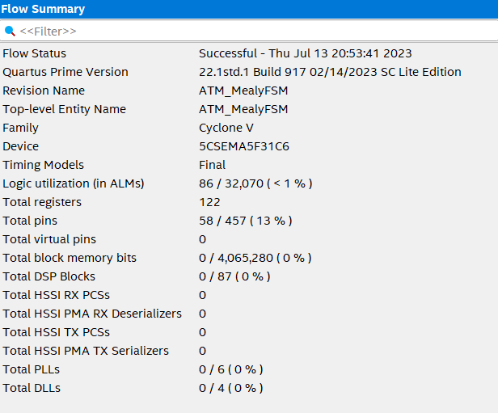

**Analysis and synthesis summary:**

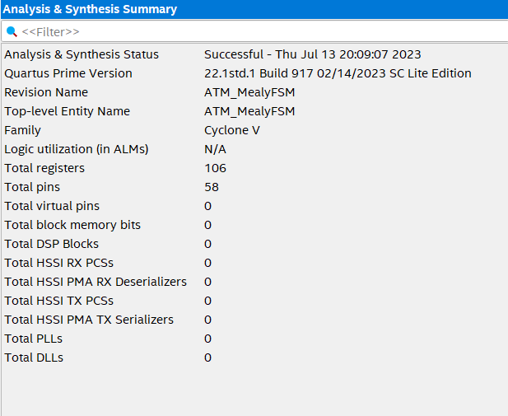

**Resource usage summary**:

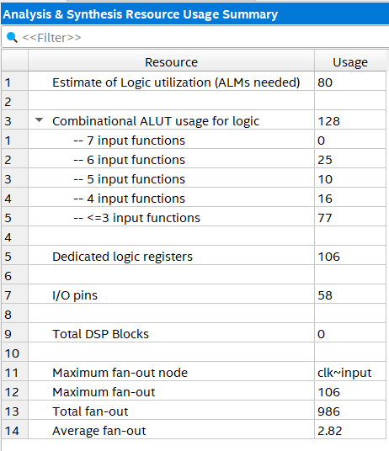

**Fitter summary**:

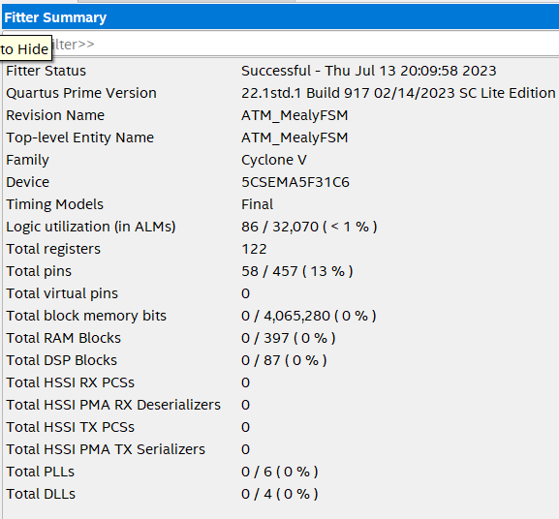

**Power analyzer summary**:

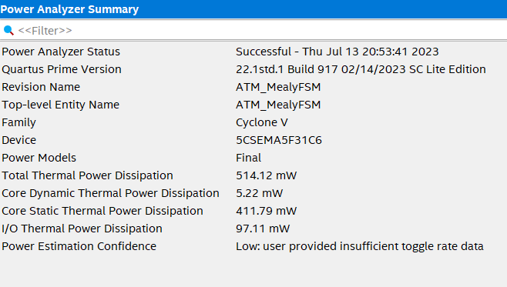

1. **Conclusion**

The provided code implements an ATM system using a Mealy Finite State Machine. It handles user interactions, PIN entry, account locking, withdrawal, facial recognition, deposit, balance display, and mini statement generation. The code includes a lock timer to automatically unlock the account after 24 hours. However, further development and integration with hardware components are required for the code to be functional.